**Open Source Selective Laser Sintering 3D Wax Printer**

Andreas Bastian

Swarthmore College Department of Engineering

Halpern Family Engineering Design Fund Project, Summer 2011

**Abstract**:  
The Selective Laser Sintering additive manufacturing process is demonstrated with a wax-based print material and an infrared laser.  The 3D-printing device was assembled quickly and simply using low-cost materials and simple tools.  The resulting device is capable of printing complex 3D objects with precision of less than a millimeter and can fabricate objects designed using several common drafting tools as well as those downloaded from the Internet.

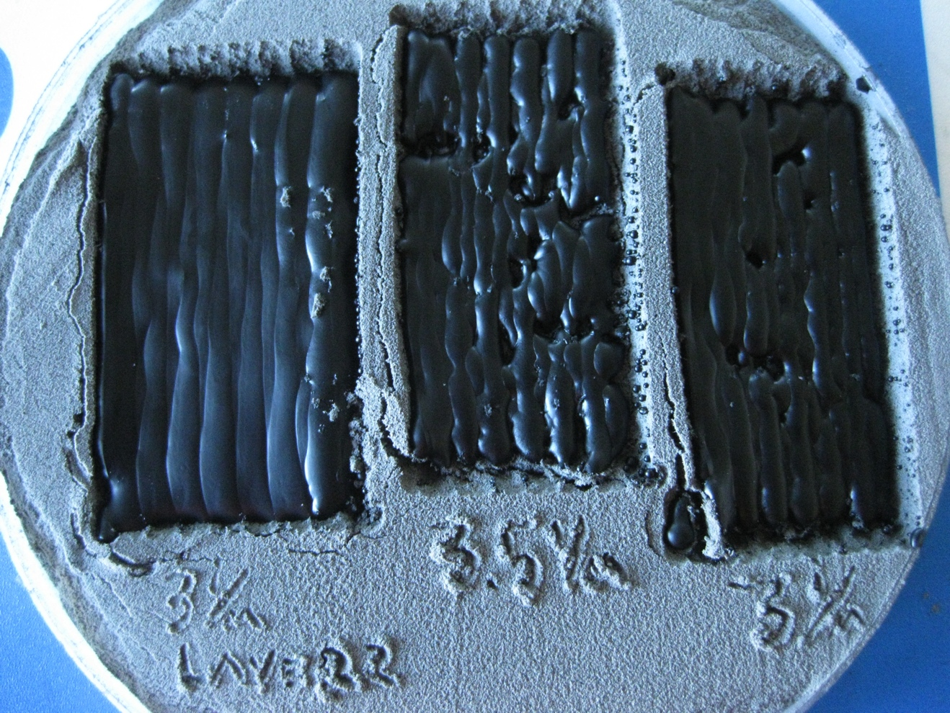

Figure 1. Early laser power tests to determine optimal sintering parameters.

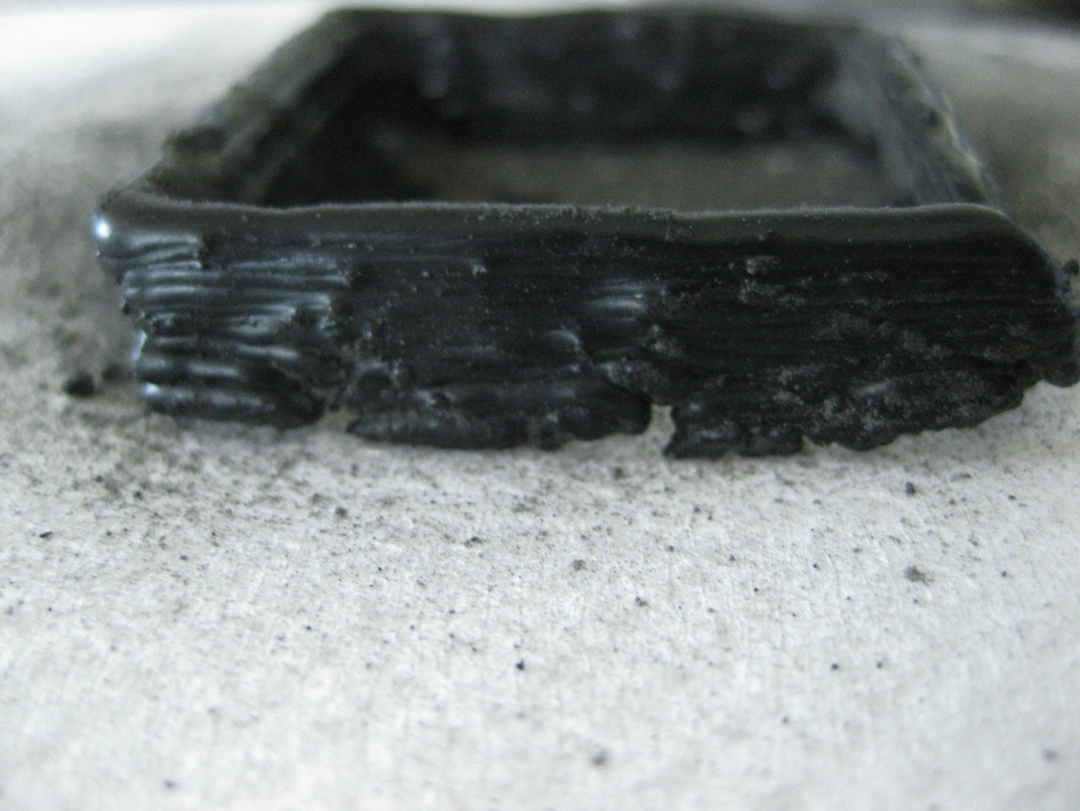

Figure 2. The first 3D print on my hardware. Layers are clearly visible, though at this early stage they are sill relatively uneven and drift in one of the translation axes has skewed the object.

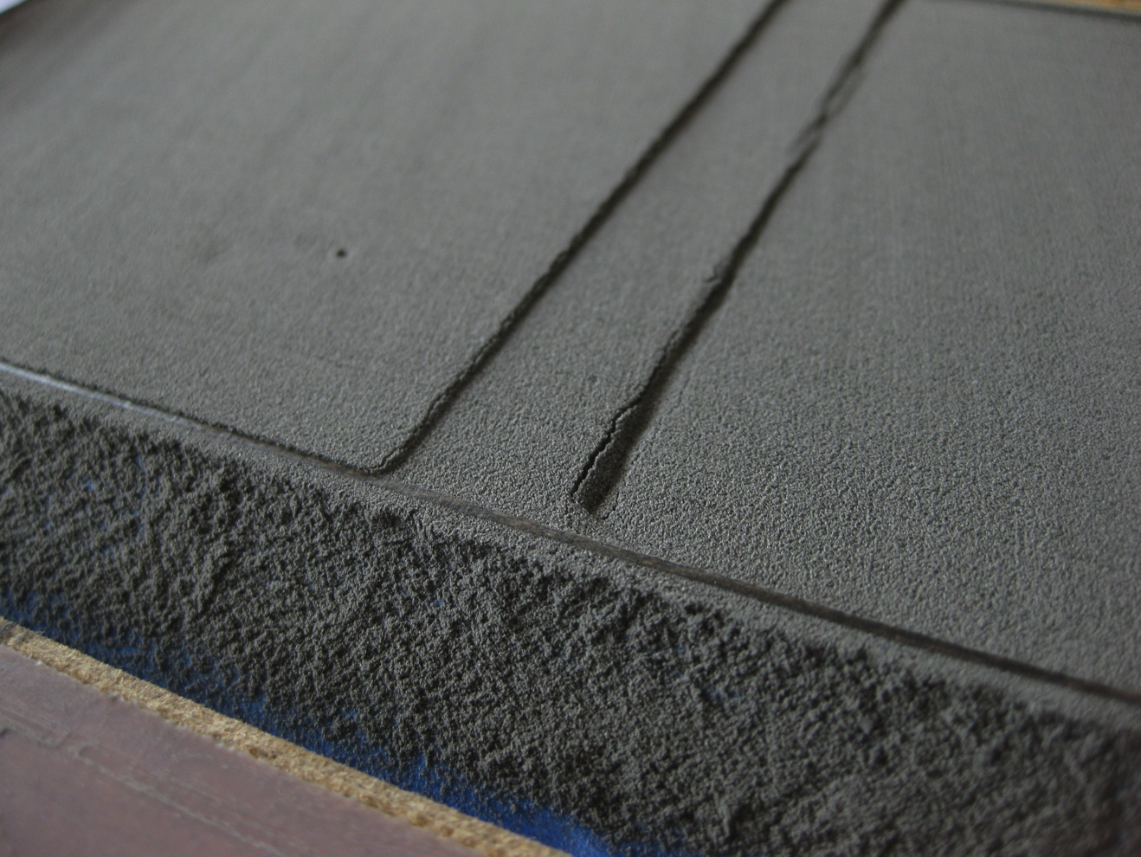

Figure 3. The print stage and powder reservoir. The print stage on the right descends and the feed piston on the left advances, providing powder for the next layer.

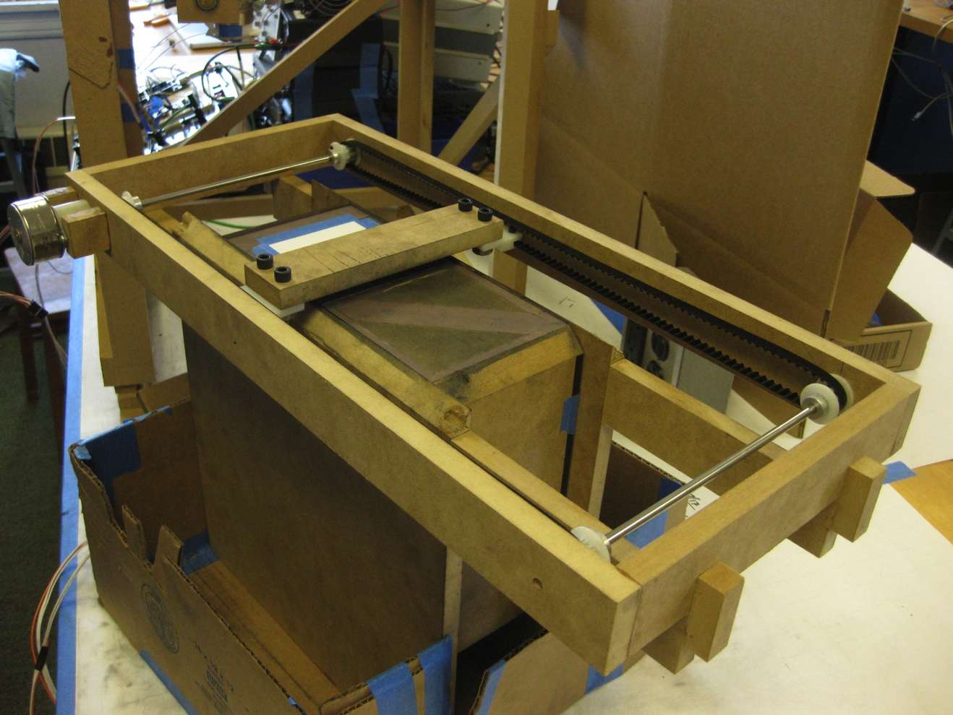

Figure 4. Powder management hardware that adds new layers of print powder when necessary.

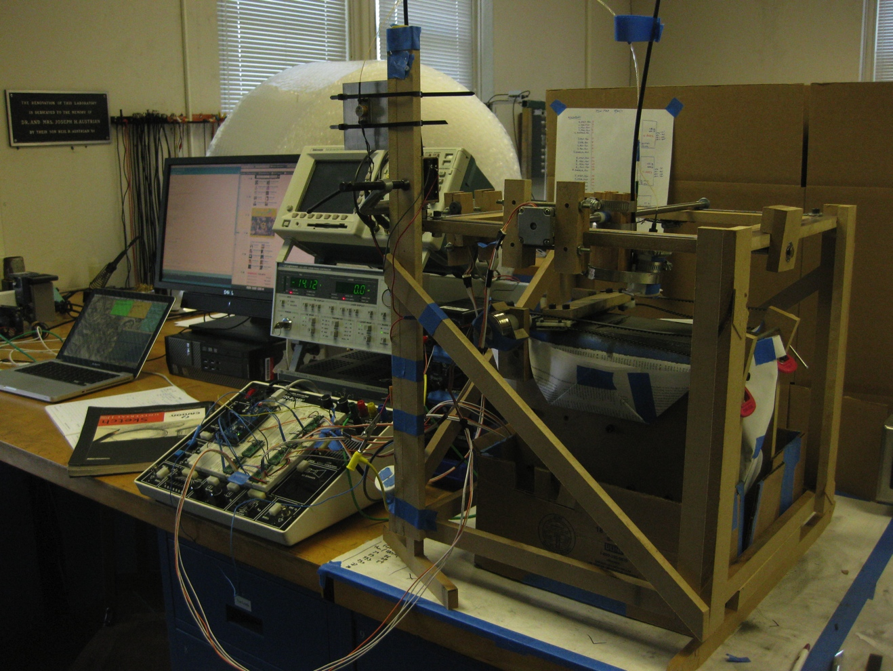

Figure 5. The printer with an early powder management hardware configuration.

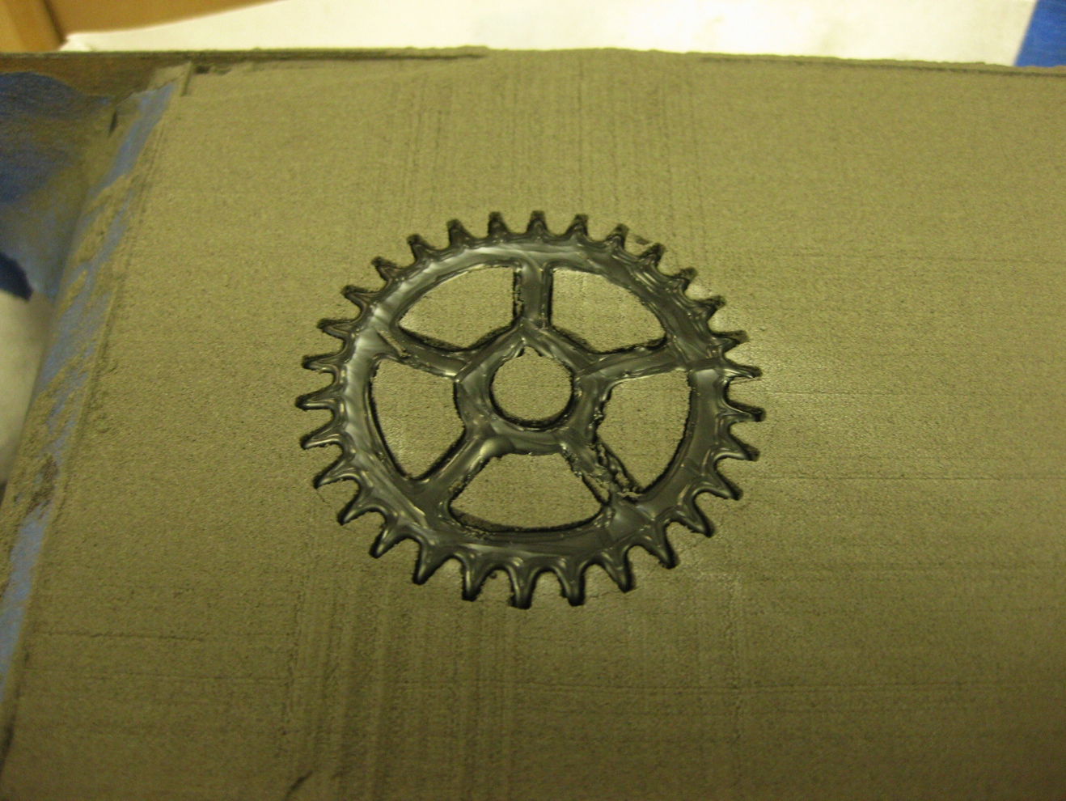

Figure 6. A gear (approximately 2” in diameter) that was designed in autoCAD and printed on my machine.

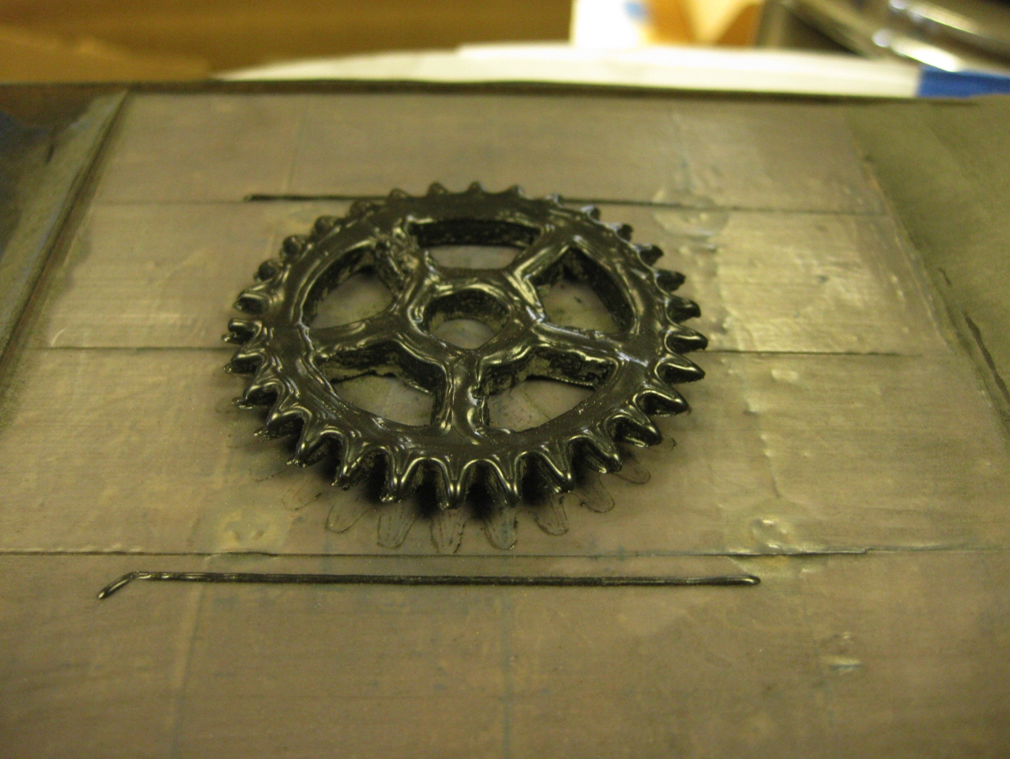

Figure 7. The gear after unsintered powder has been removed.

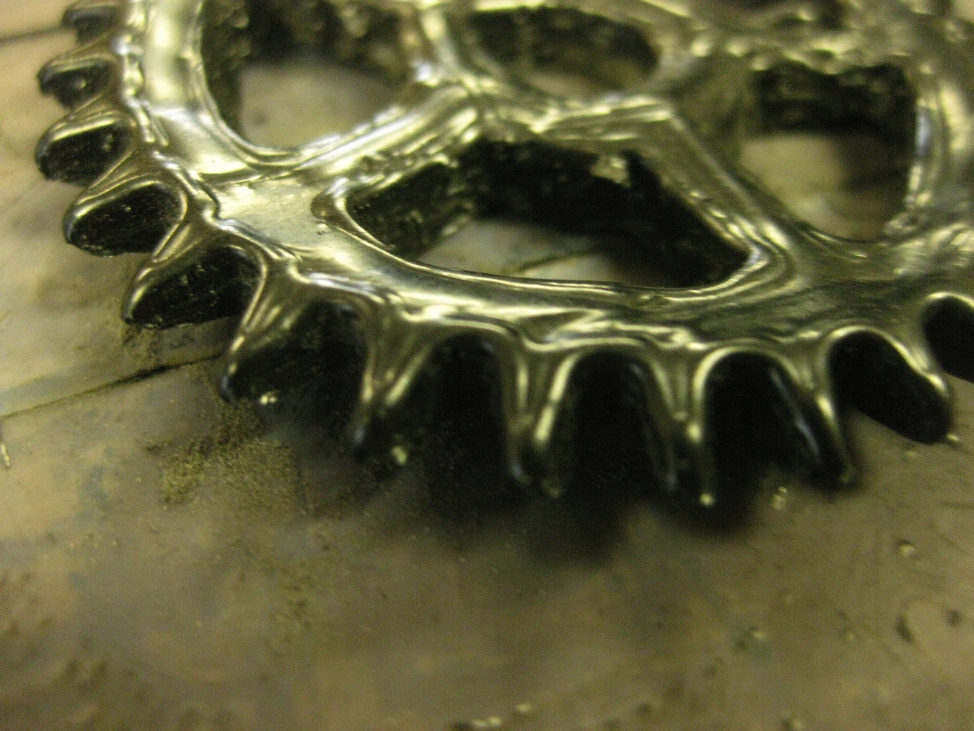

Figure 8. Detail of the precision of the sintering process and of defects in the print.

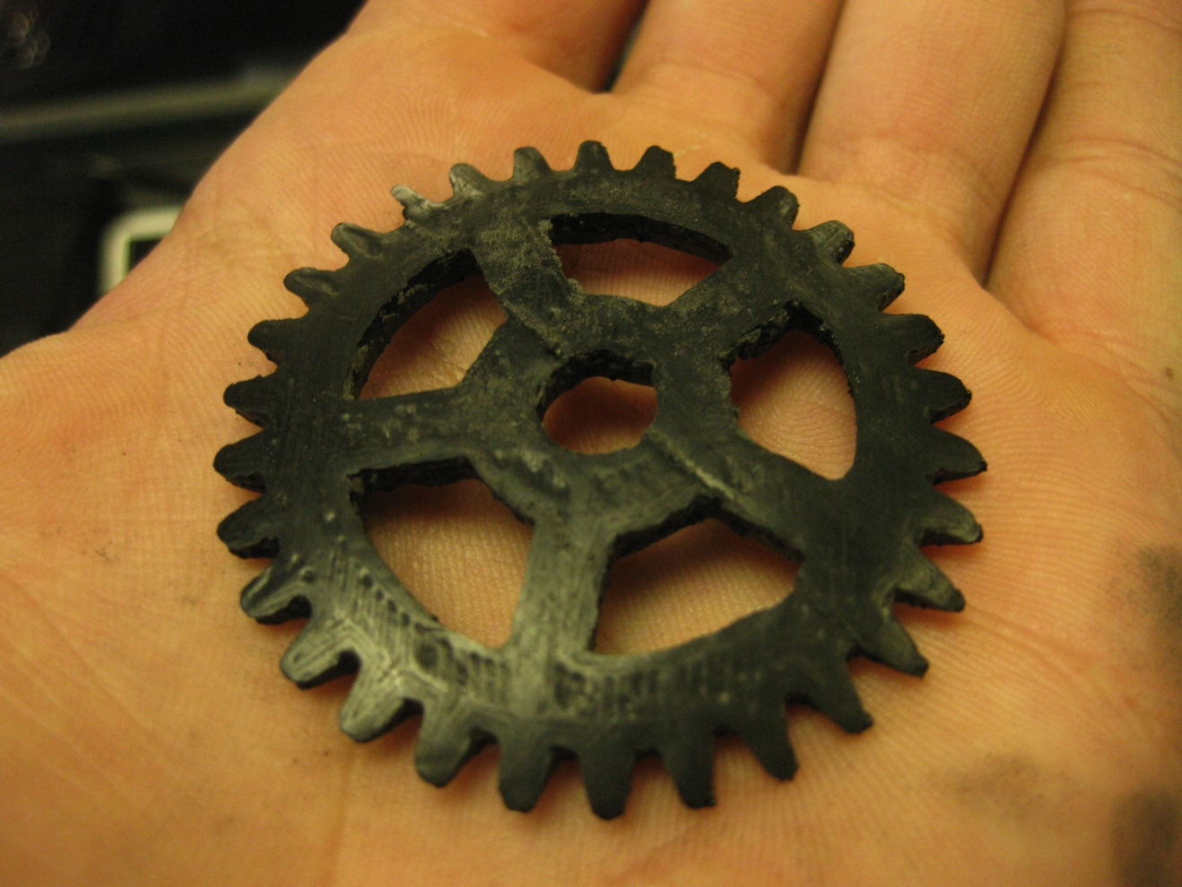

Figure 9. The underside of the gear.

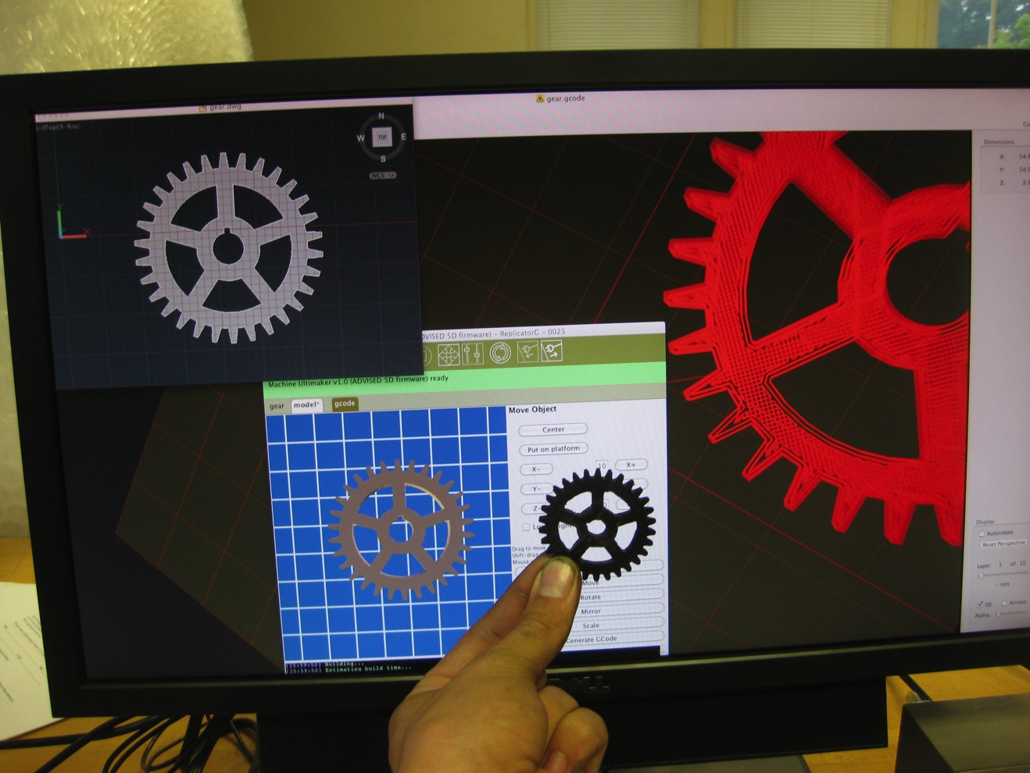

Figure 10. The design process and results. From the top left, counter-clockwise, the original design in autoCAD, the imported .stl in replicatorG, the finished printed piece, and a visualization of the laser tool path.

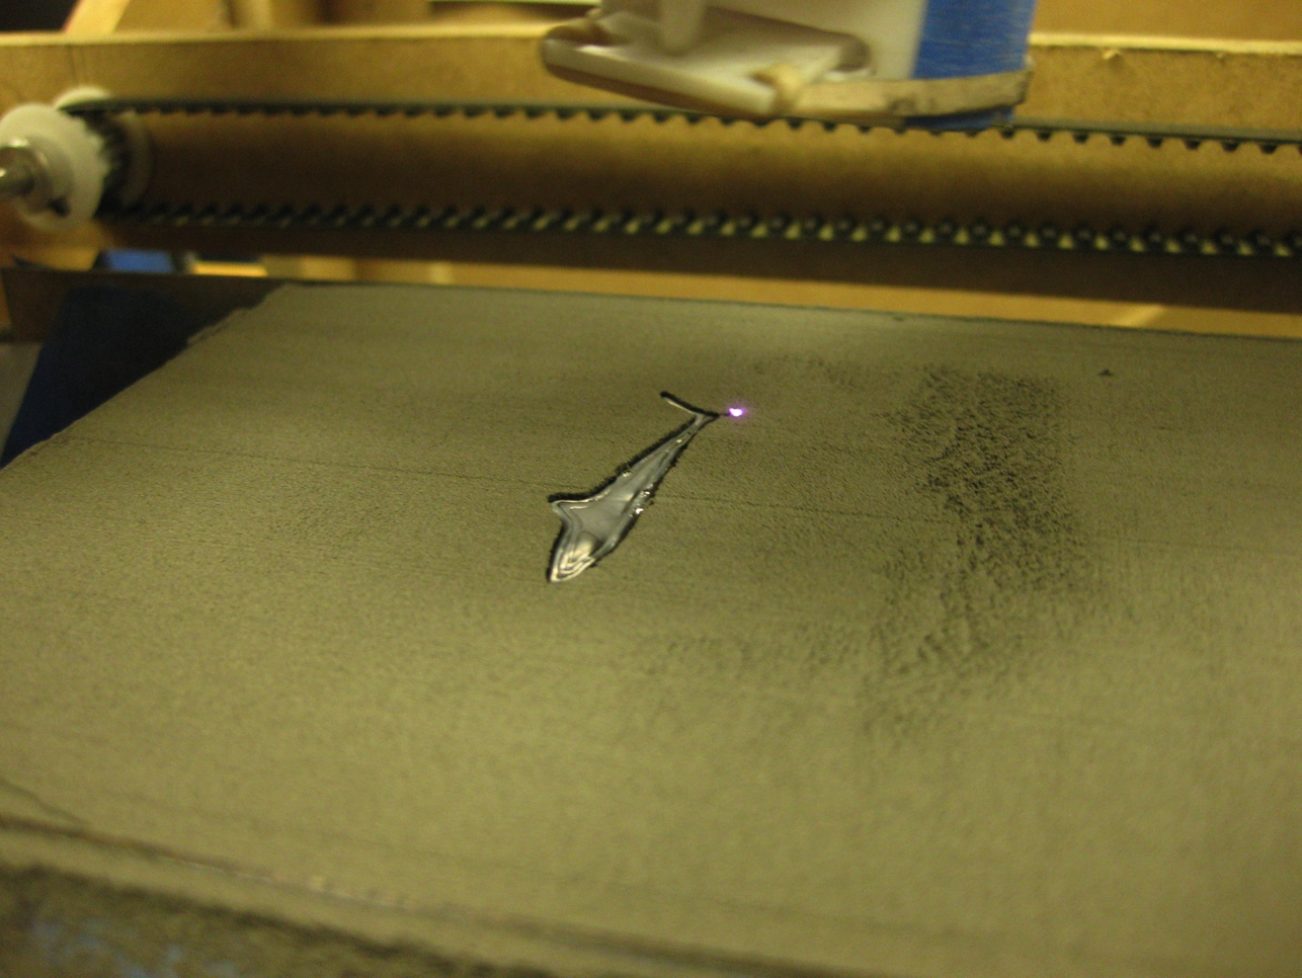

Figure 11. Printing a shark downloaded from Thingiverse.

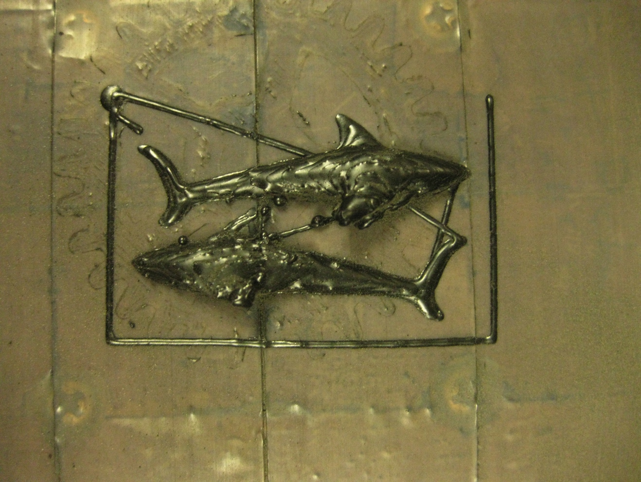

Figure 12. The completed shark (print time under 20 min). Still some defects due to inconsistencies in print powder density.

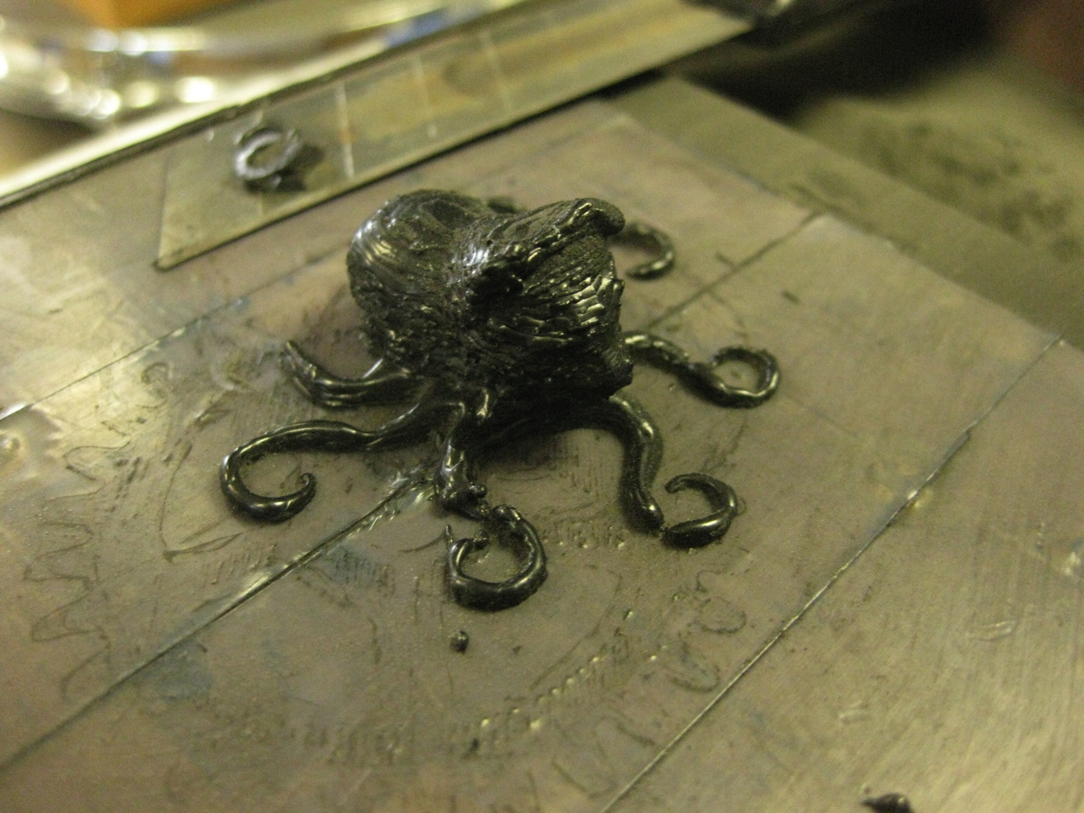

Figure 13. Another Thingiverse print. Cleaner layers, but still some defects.

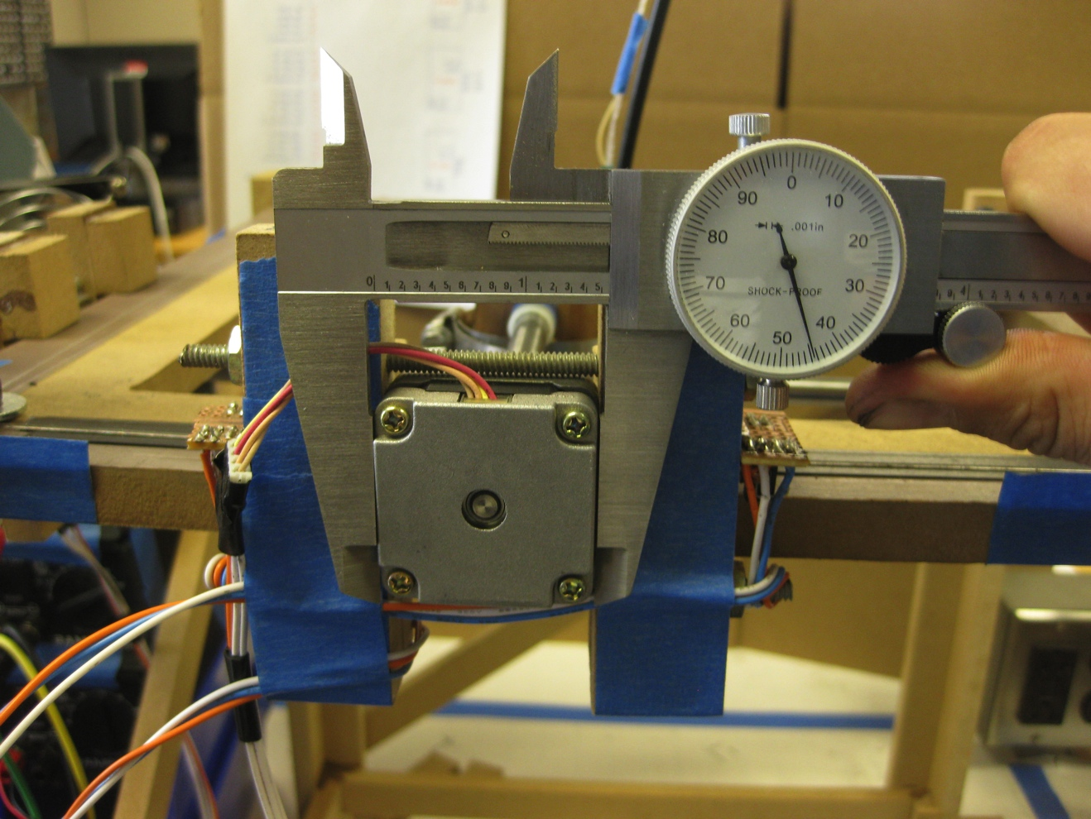

Figure 14. Demonstration of the intended workflow. If a user wants to make a part, they can take measurements based on the application. In this case, measurements were taken for the design of a stepper motor heatsink for use on the translation system.

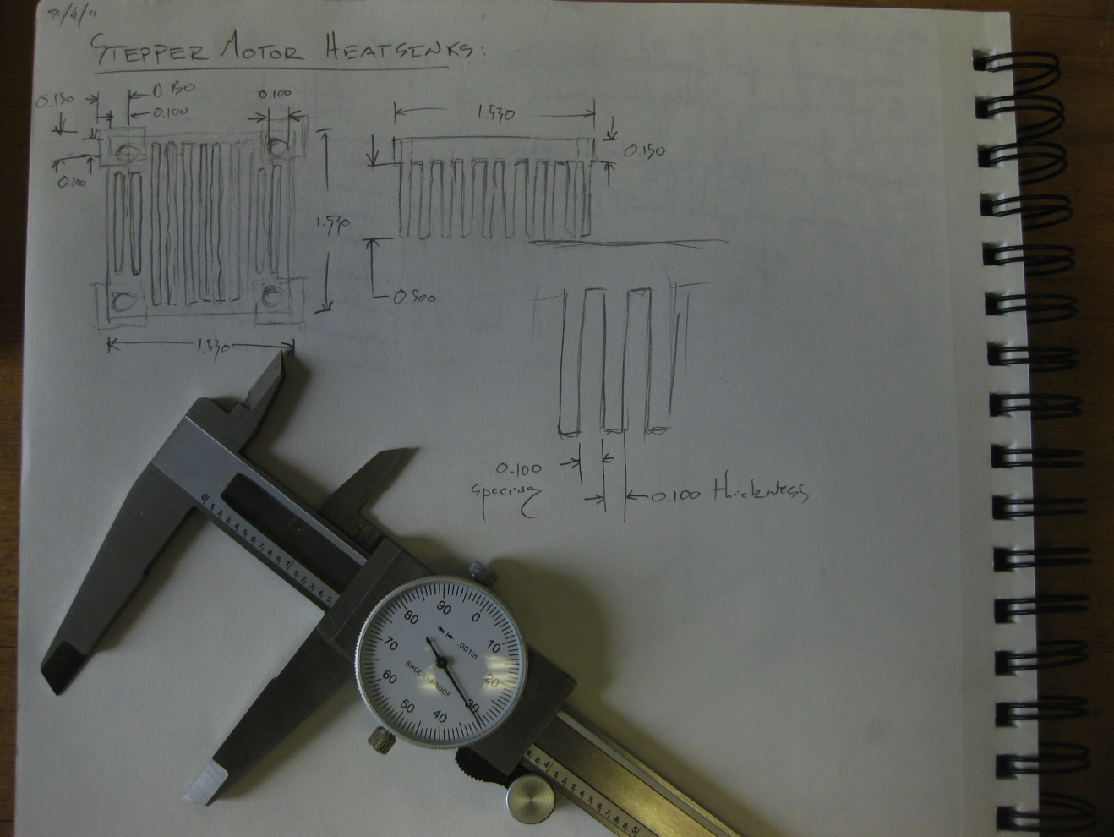

Figure 15. Designing the stepper motor heat sink.

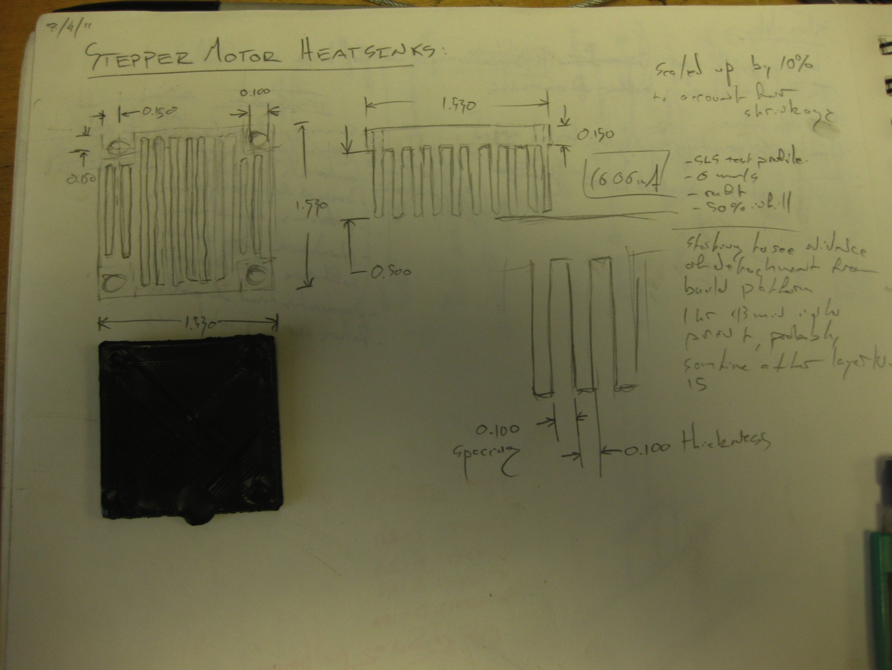

Figure 16. The printed heat sink. Due to an electronics problem, the print had to be aborted, but the incomplete part proved useful in demonstrating the ultimate plan for this process.

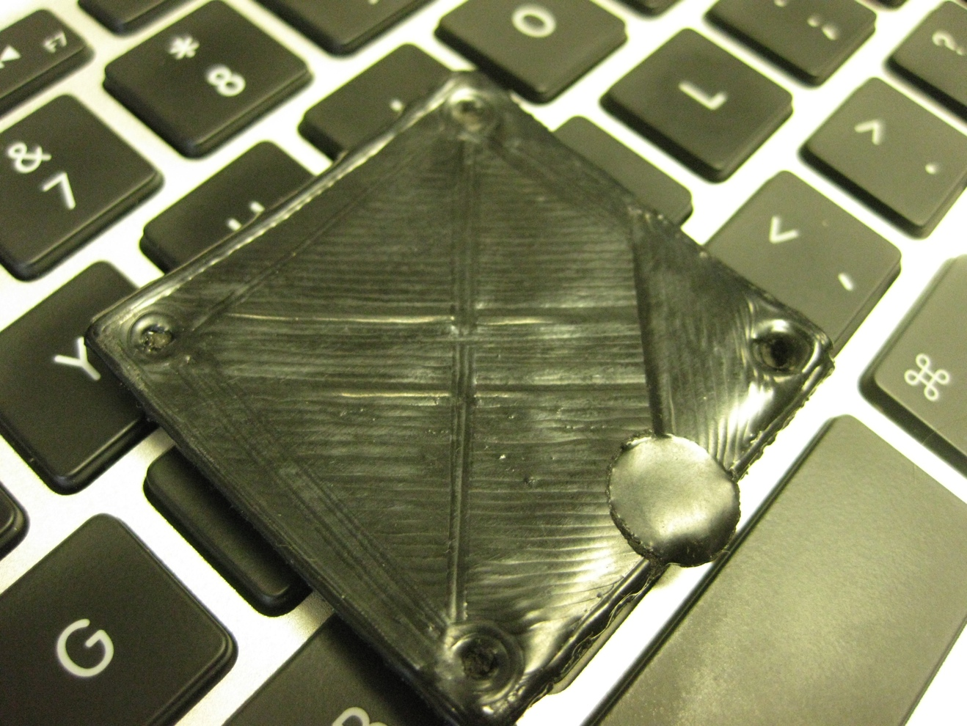

Figure 17. The incomplete heat sink. Note where the laser melted a portion of the print when the translation system crashed. Detail resolution was good and infilling was robust.

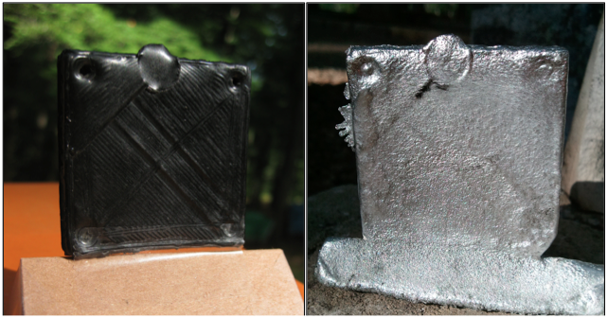

Figure 18. Demonstration of the lost-wax casting process intended for use with this printer. The part was cast in Zinc.